DAA ASSIGNMENT -3
Name: G.Ragavendar
roll no:ch.sc.u4cse24260
1) BFS:
Code:
#include <stdio.h>
int n;
int graph[20][20];
int visited[20];
int queue[20];
int front = 0, rear = -1;
void bfs(int start)
{
int i, v;
queue[++rear] = start;
visited[start] = 1;
while (front <= rear)
{
v = queue[front++];
printf("%d ", v);
for (i = 0; i < n; i++)
{
if (graph[v][i] == 1 && visited[i] == 0)
{
queue[++rear] = i;
visited[i] = 1;
}
}
}
}
int main()
{
int i, j, start;
scanf("%d", &n);
for (i = 0; i < n; i++)
for (j = 0; j < n; j++)
scanf("%d", &graph[i][j]);
for (i = 0; i < n; i++)
visited[i] = 0;
scanf("%d", &start);
bfs(start);
return 0;
}
O/p:
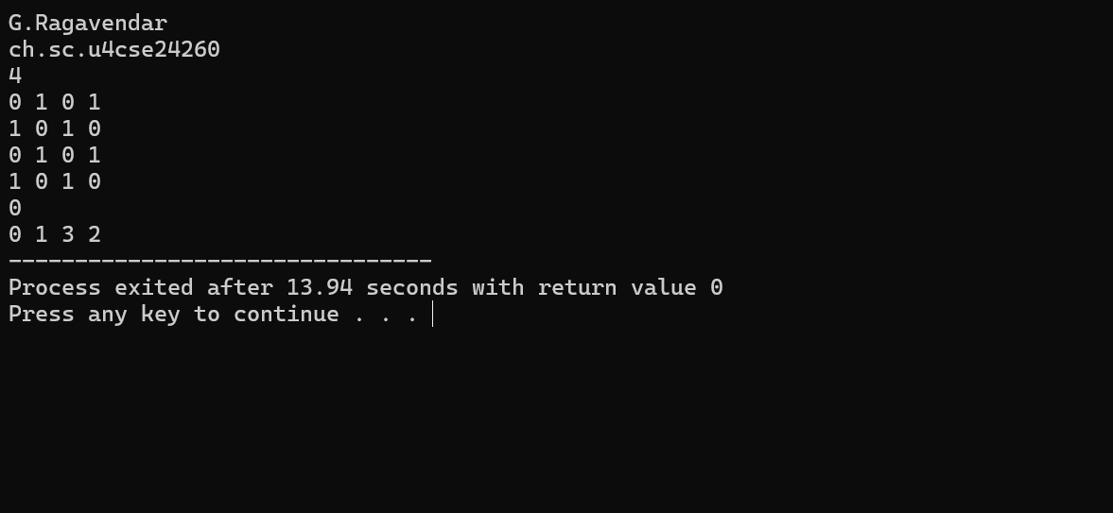

Interpretation:
Breadth First Search (BFS) is a graph traversal method that explores nodes level by level, starting from a given source node.

How BFS Works (Interpretation Steps)
- Start from a given node
- Visit it and mark it as visited
- Visit all its immediate neighbours
- Then visit neighbours of those neighbours
- Continue until all reachable nodes are visited
2)DFS:
Code:
#include <stdio.h>
int n;
int graph[20][20];
int visited[20];

void dfs(int v)
{
int i;
printf("%d ", v);
visited[v] = 1;
for (i = 0; i < n; i++)
{
if (graph[v][i] == 1 && visited[i] == 0)
dfs(i);
}
}
int main()
{
int i, j, start;
scanf("%d", &n);
for (i = 0; i < n; i++)
for (j = 0; j < n; j++)
scanf("%d", &graph[i][j]);
for (i = 0; i < n; i++)
visited[i] = 0;
scanf("%d", &start);
dfs(start);

return 0;
}
O/p:
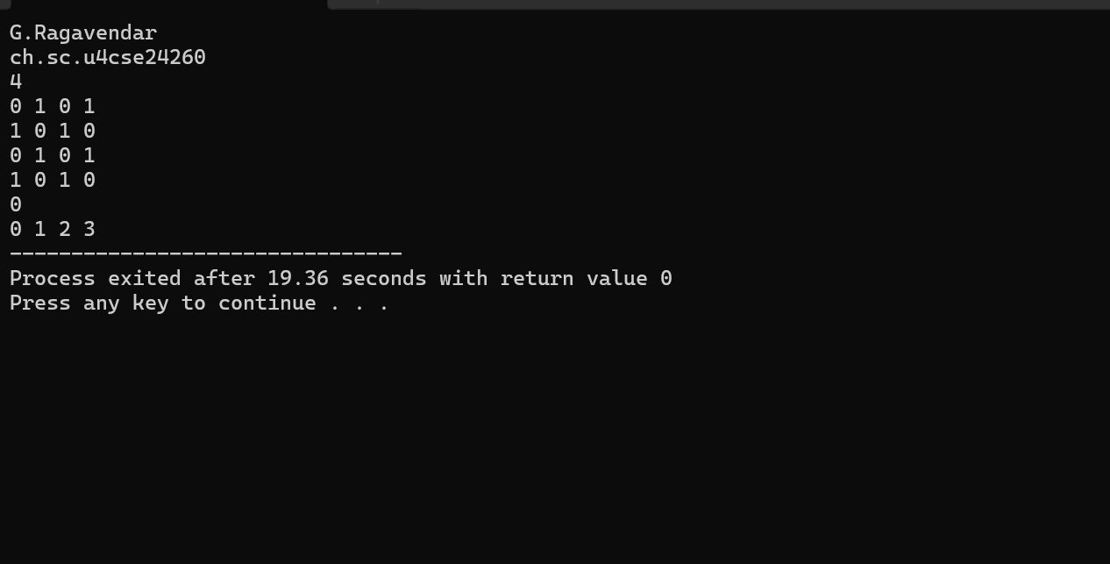

Interpretation:
Depth First Search (DFS) is a graph traversal technique that explores a graph by going as deep as possible along one path before backtracking.

How DFS Works (Interpretation Steps)
- Start from a given node
- Visit it and mark it as visited
- Move to one unvisited adjacent node
- Repeat step 3 until no more adjacent nodes are left
- Backtrack and continue with remaining nodes

